1. 
2. Sometimes, we want to deploy our app in JBOSS Server then we need to package our app as WAR not JAR.
3. In this lecture, we will use Tomcat as external Server.  
   Let’s create REST Project with packaging War.
4. 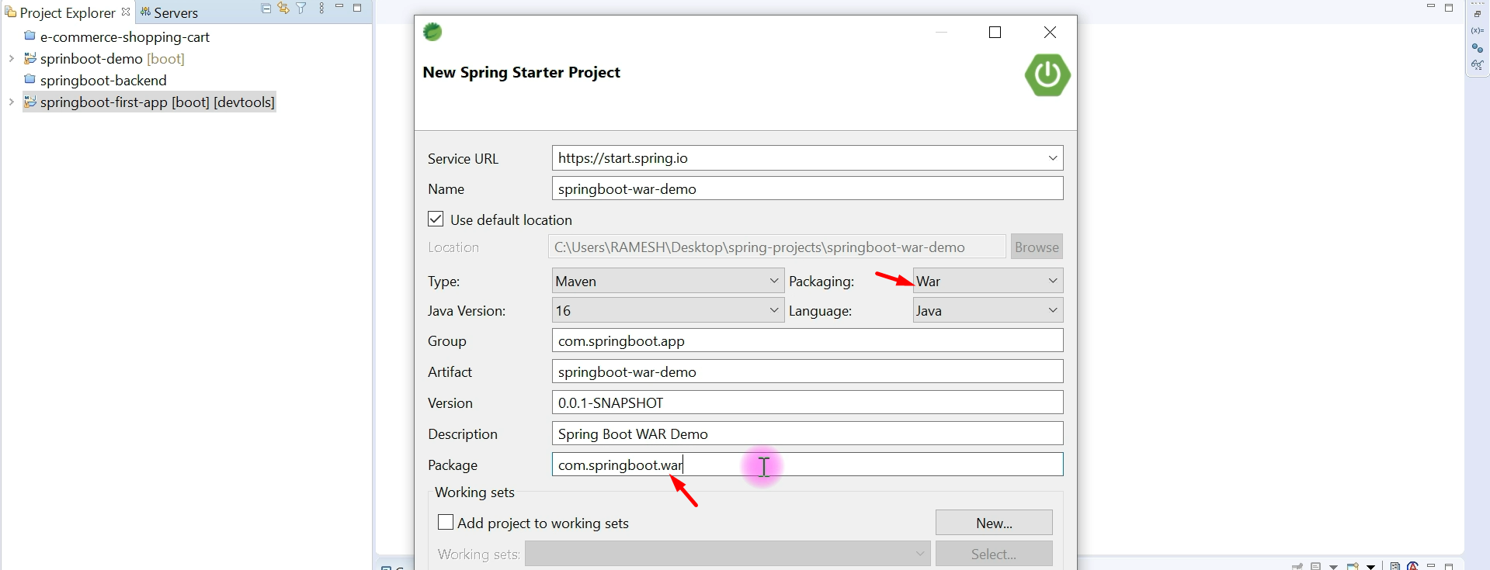
5. 
6. 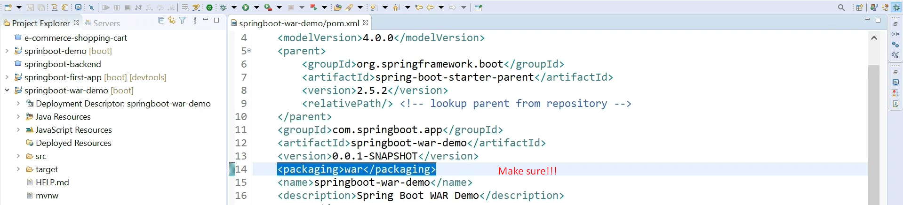
7. 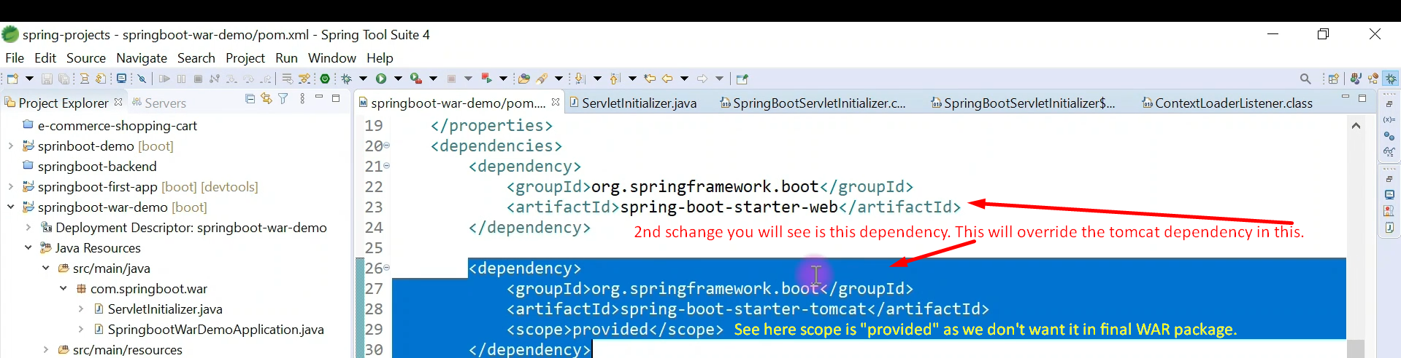
8. 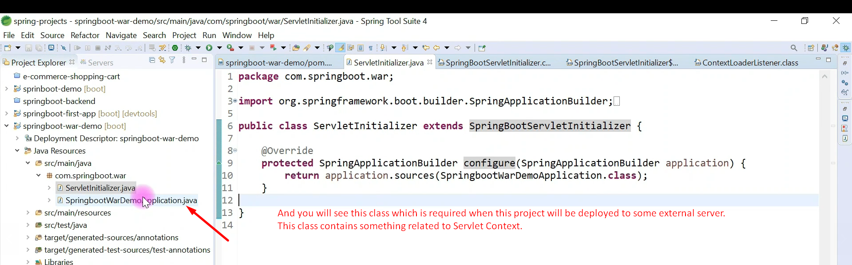
9. 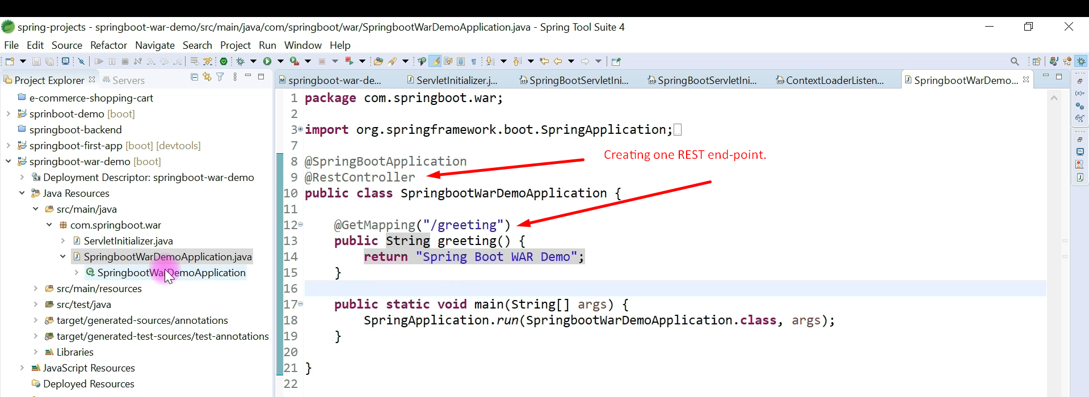
10. 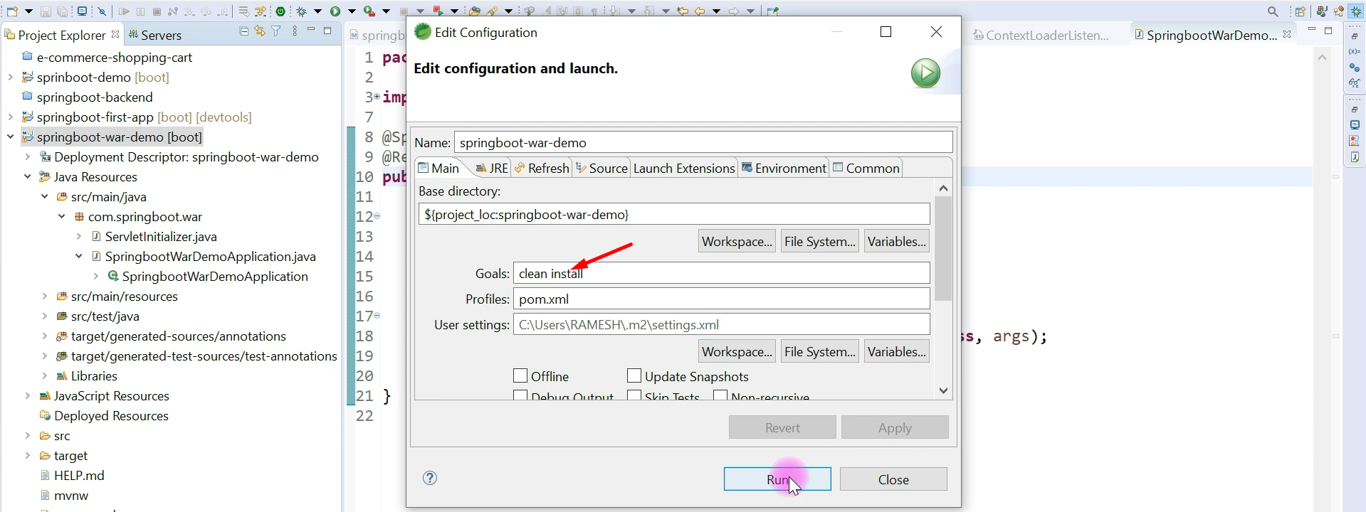
11. 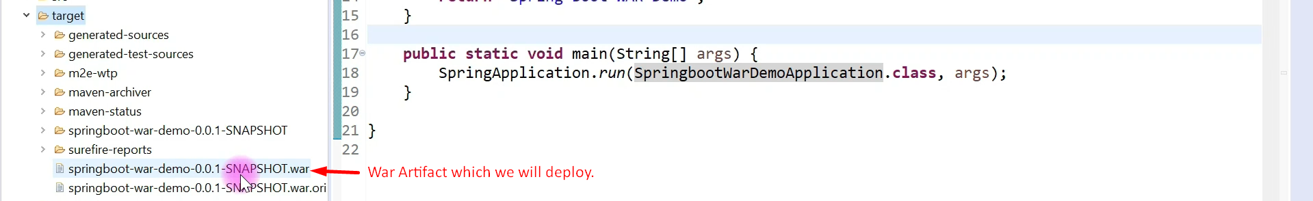
12. 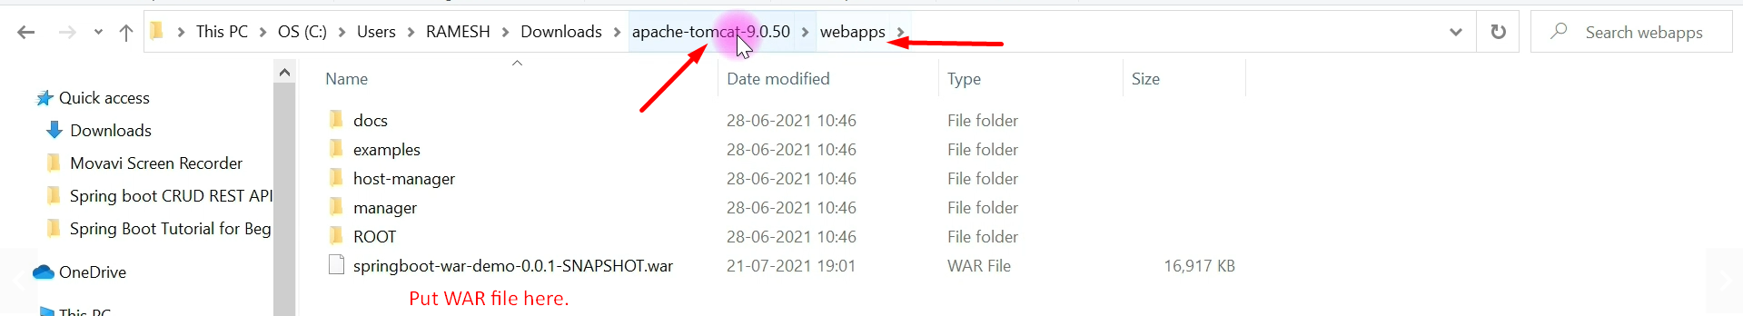
13. 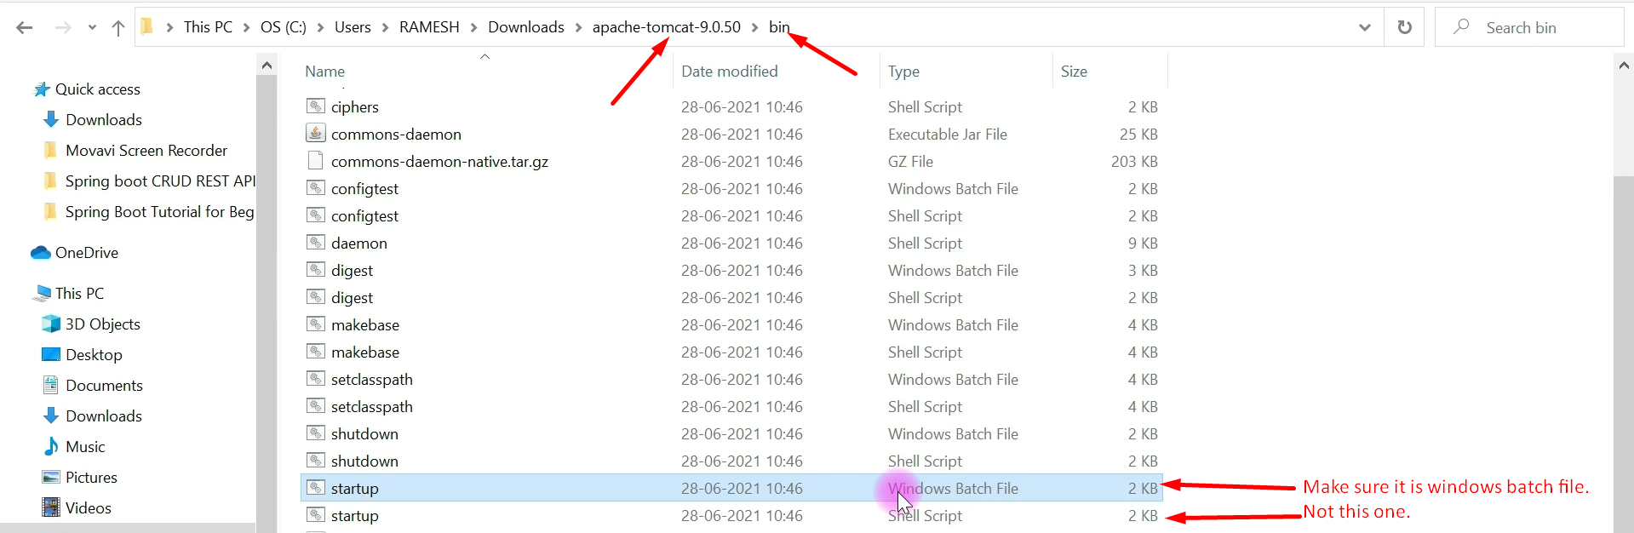
14. 
15. 